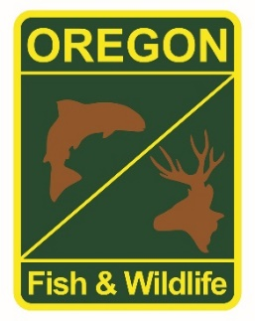

**State Fisheries Genetics Lab Tissue Sample Intake Form**

Please complete the top part of this form and send to: [kathleen.omalley@oregonstate.edu](mailto:kathleen.omalley@oregonstate.edu)

Make arrangements with us prior to dropping off the tissue samples and include a copy of this form with your samples.

**Project dropping off samples: Rogue Fish District**

**Person dropping off samples: Dan VanDyke**

**Phone: 541-826-8774 x234 Email:daniel.j.vandyke@state.or.us**

**Description of samples (e.g. species, collection locations, collection dates, collection methods, number of samples, life stage; may attach spreadsheet):**

**Rogue Spring Chinook. Locations on sample cards with key to abbreviations on spreadsheet which has samples individually identified by number and date . Samples collected from spawned adults with scissors from various fins. Spreadsheet attached.**

**If applicable, known origin (e.g. natural or hatchery): All samples except 3 collected from wild fish (intact adipose fin).**

**Sample type (e.g. fin tissue, scale, muscle, etc): Variable fin tissue.**

**Storage method (e.g. dry, 95% ethanol, RNA later, etc):** Dry.